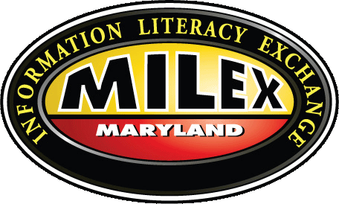 | MILEX 2026 Spring Conference  Friday, April 24, 2026  09:30 AM – 03:30 PM  Room 412, Robert L. Bogomolny Library, University of Baltimore  1420 Maryland Avenue, Baltimore, MD 21201

Democracy + Information Literacy Instruction

Schedule

09:00 AM – 09:30 AM: Breakfast and networking
09:30 AM – 09:45 AM: Welcome and introductions
09:45 AM – 11:00 AM: Keynote + Q+A: Dr. Paul T. Jaeger
11:00 AM – 11:15 PM: Break
11:00 AM – 12:00 PM: Keynote debrief: What is democracy? How do academic libraries support it?
12:00PM – 12:45 PM: Lunch
12:45 PM – 01:45 PM: Article deep-dive: Lupien & Rourke (2021)
01:45 PM – 02:00 PM: Break
02:00 PM – 02:45 PM: Short article discussions
02:45 PM – 03:30 PM: Wrap up: What can information literacy librarians do for democracy? What can MILEX do?

The Maryland Information Literacy Exchange (MILEX) is a collaborative of Maryland academic librarians promoting information literacy in higher education.

